PHASE 3 PROJECTWALKTHROUGH

INTRODUCTION
This project implements a real-time ride sharing analytics platform using Apache Kafka and Python. The objective is to simulate ride events, process streaming data through multiple Kafka topics, calculate driver earnings, and generate analytical reports.
The application follows an event-driven architecture where each component performs a dedicated task and communicates through Kafka topics. This approach improves scalability, flexibility, and maintainability while enabling real-time processing of ride information.

PROJECT OBJECTIVES
The major objectives of this project are:
- Generate ride events using a Kafka Producer.
- Stream ride data through Kafka topics.
- Filter completed rides from incoming ride events.
- Calculate driver earnings based on completed rides.
- Generate a report showing top performing drivers.
- Demonstrate real-time event processing using Apache Kafka.

SYSTEM ARCHITECTURE
The system consists of three Kafka topics and multiple processing stages.
Workflow:
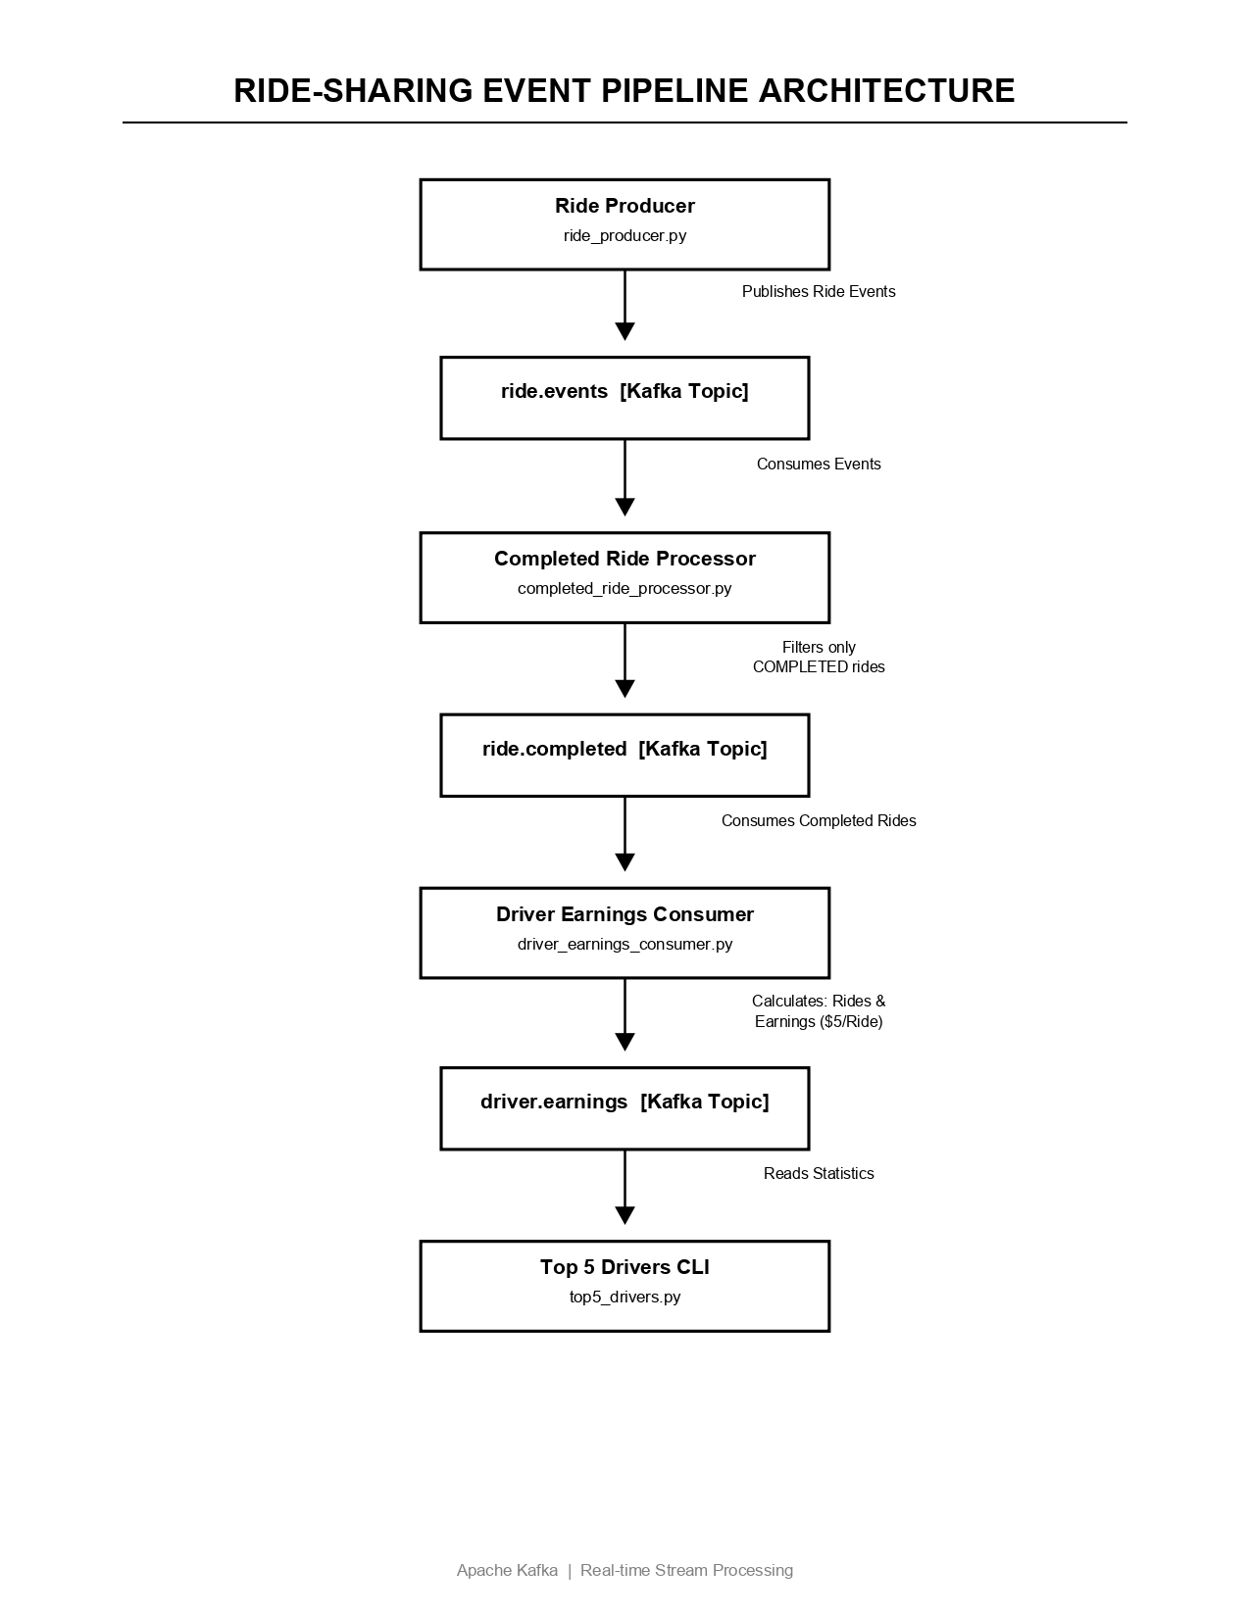

KAFKA TOPICS USED
Topic 1: ride.events
This topic stores every ride event generated by the producer. Each message contains:
Ride ID
• Driver ID
• Rider ID
• Ride Status
• Latitude
• Longitude
• Timestamp
Possible ride statuses:
REQUESTED
• ACCEPTED
• COMPLETED
• CANCELLED
Topic 2: ride.completed
This topic contains only completed ride events. It acts as an intermediate processing layer between raw ride events and driver analytics.
Topic 3: driver.earnings
This topic stores processed driver statistics including completed ride counts and earnings information.

RIDE EVENT GENERATION

The ride_producer.py application acts as the Kafka Producer.
The producer reads ride records from rides.csv and publishes them to the ride.events topic.
Each record is converted into a Kafka message and sent to the broker. This simulates real-world ride requests generated continuously by a ride-sharing platform.
The producer successfully publishes all ride events into Kafka for downstream processing.
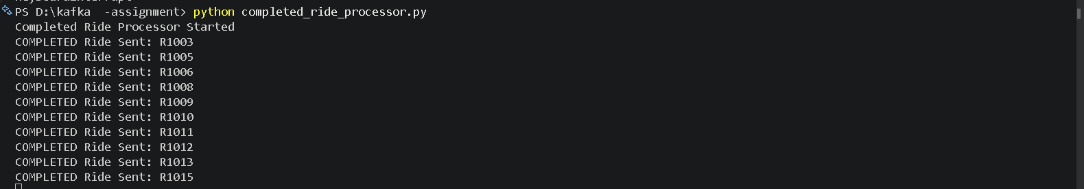
Fig:. Ride Producer Publishing Events to ride.events Topic

COMPLETED RIDE FILTERING
The completed_ride_processor.py application subscribes to the ride.events topic.
Each incoming ride event is evaluated based on its status.
Processing Logic:
If Status = COMPLETED
→ Forward message to ride.completed topic
Otherwise
→ Ignore message

This filtering mechanism ensures that only relevant business events are processed further for earnings calculation.
The filtering stage demonstrates one of the most common patterns used in event-driven systems.
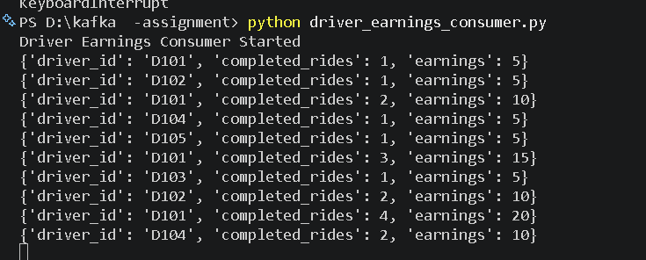
Fig. Filtering and Forwarding Completed Ride Events

DRIVER EARNINGS PROCESSING
The driver_earnings_consumer.py application consumes messages from the ride.completed topic.
For each completed ride:
- Driver ride count is incremented.
- Earnings are updated.
The earnings model used in this project is intentionally simple.
Formula:
Total Earnings = Completed Rides × $5
Example:
Completed Rides = 4
Earnings = 4 × $5 = $20
The consumer continuously updates driver statistics whenever new completed rides arrive.
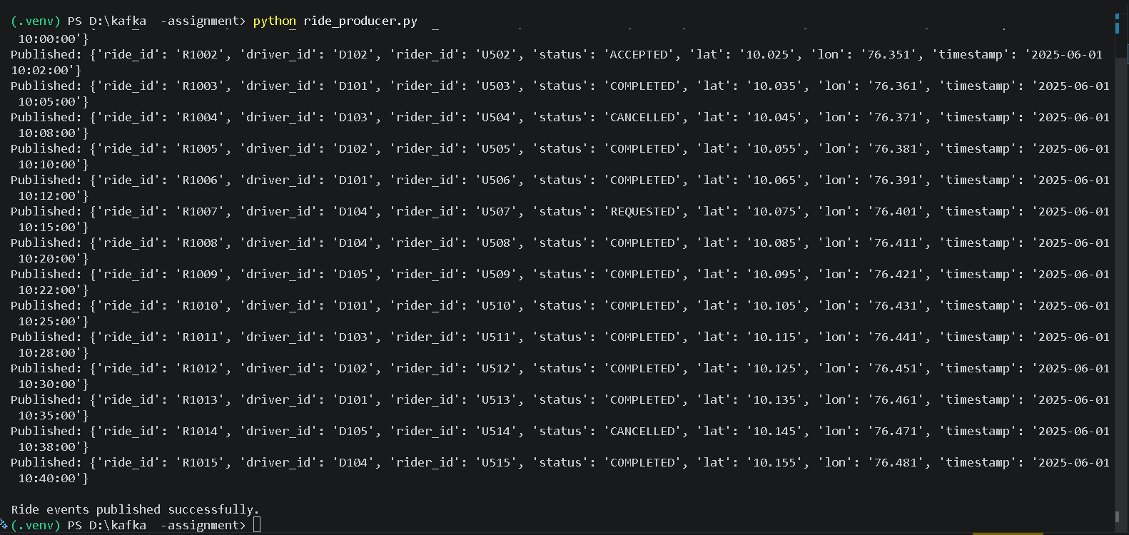
Fig:. Driver Earnings Calculation and Aggregation

TOP DRIVER ANALYTICS
The top5_drivers.py module generates a ranking of drivers according to ride completion statistics.
The report helps identify:
- Most active drivers
- Highest earning drivers
- Driver performance trends
The output displays the five best performing drivers in descending order based on completed rides.
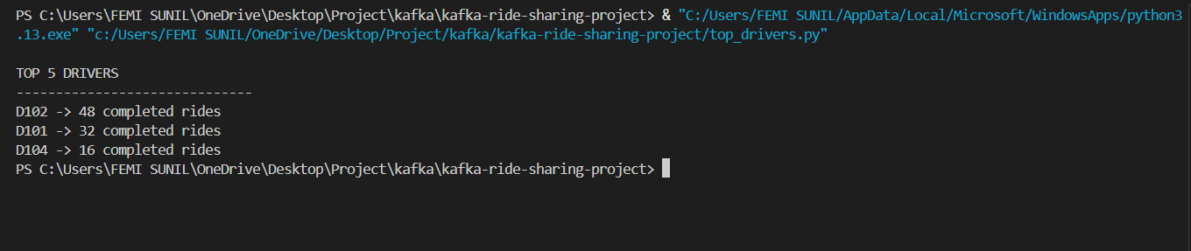
Fig. Top 5 Driver Performance Report

DESIGN DECISIONS
Why Apache Kafka?
Apache Kafka was selected because it provides:
- High Throughput
- Distributed Architecture
- Scalability
- Reliability
- Fault Tolerance
Why Event-Driven Processing?
Benefits include:
- Loose coupling between services
- Independent scaling
- Real-time communication
- Easier maintenance
Why Multiple Topics?
Separating topics improves:
- Data organization
- System maintainability
- Processing efficiency
- Future extensibility

TEST EXECUTION
The project was executed successfully using the following sequence:
Step 1:
Start Kafka Broker using Docker.
Step 2:
Create Kafka Topics.
Step 3:
Execute ride_producer.py.
Step 4:
Verify messages in ride.events.
Step 5:
Execute completed_ride_processor.py.
Step 6:
Verify completed rides in ride.completed.
Step 7:
Execute driver_earnings_consumer.py.
Step 8:
Generate Top Drivers Report.
All modules communicated successfully through Kafka topics.

RESULTS
The system successfully achieved all project objectives.
Achievements:
- Real-time ride event generation
- Kafka topic communication
- Event filtering
- Driver earnings aggregation
- Top driver reporting
- Event-driven architecture implementation
- Real-time analytics processing

CONCLUSION
The Ride Sharing Analytics Pipeline demonstrates the practical implementation of Apache Kafka for building real-time event-driven applications.
The project successfully streams ride events, filters completed rides, calculates driver earnings, and generates driver performance reports. Through this implementation, important Kafka concepts such as Producers, Consumers, Topics, Event Filtering, Stream Processing, and Real-Time Analytics were explored and validated.
The architecture is modular and can be extended further to support large-scale ride-sharing systems, live dashboards, fraud detection, and advanced analytics applications.

